Name Date

The Hundredth Anniversary of the Titanic Sinking

1. Pronunciation

The sound of AY as in fry, why, sky, my
Pronounce these words in pairs:
free-fry, me-my, sea-sigh, be-buy, tree-try
I tried to dye my tie.

2. Vocabulary
1. collide-(v) - To hit or crash into something.
2. liner-(n) - A ship that travels between two points.
3. Titanic-(adj) - Of giant size or strength.
4. lack-(v) - Not have something.
5. seek-(v) - Look for.
6. flood-(v) - To put too much in, so what is coming in cannot be controlled or handled.
7. dip-(v) - To drop suddenly.
8. sink-(v) - To fall or drop, usually through water.
9. survive-(v) - To stay alive.
10. due to-(adj) - Because of.
11. rate-(n) - A ratio that compares two different measurements.
12. plunge-(v) - To push into quickly, like a rock falling into water.

3. Reading
Fill out the 'K' and the 'W' columns before you read, and then use the 'L' column to take notes while you read.
K | W | L
What do you KNOW about the Titanic | What do you WANT to know about the Titanic | What did you LEARN about the Titanic

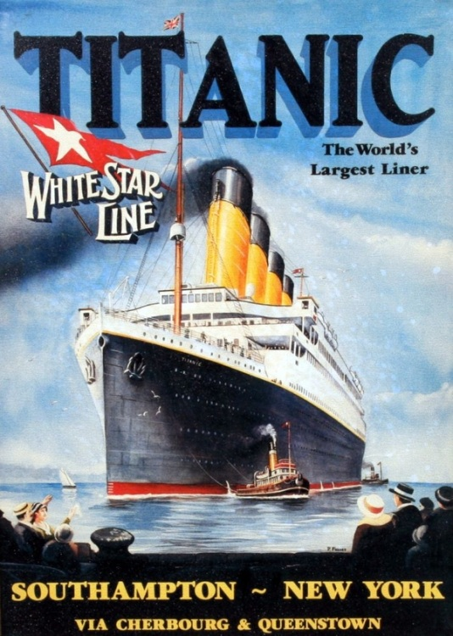
Introduction
The RMS Titanic was a British passenger liner that sank in the North Atlantic Ocean on 15 April 1912. The ship was on its maiden voyage from England to New York City when it collided with an iceberg. 1,514 people to died when the ship sank.
In 1912, the Titanic was the largest passenger ship in the water, carrying 2,224 people . It was 882 feet long and weighed 46,328 tons. The ship was supposed to feature an “unsinkable” design alongside a luxurious experience. The ship had a swimming pool, libraries, fancy restaurants and cabins. The Titanic had special watertight compartments, but it lacked enough lifeboats for the number of people on board.
Her passengers included some of the wealthiest people in the world, as well as over a thousand emigrants seeking a new life in North America.
The Collision
On 14 April 1912, four days into the crossing at 11.40 pm, lookout Frederick Fleet spotted an iceberg immediately ahead of Titanic and alerted the bridge. First Officer William Murdoch ordered the helmsman to steer the ship around the obstacle. The order came too late and the side of Titanic struck the iceberg. Five of the ship's watertight compartments started to flood. It soon became clear that the ship was doomed. The Titanic began sinking bow-first.
The people on the Titanic were not prepared for the emergency. The ship's lifeboats only had enough space to carry about half of the people. The crew had not been trained well on how to get the people off the boat and into the lifeboats. Third-class passengers did not receive much help and many were trapped below decks as the ship filled with water. Many men were left aboard due to a "women and children first" rule for loading the lifeboats.
Two hours and forty minutes after Titanic struck the iceberg, she suddenly started to sink at a faster rate. The front deck dipped underwater and the sea poured in. The ship split apart from pressure. At 2.20 am, the last part of the ship sank, with over a thousand people still on board. These passengers and crew were plunged into deadly cold water. The water was only 28 °F, so almost everyone in the water died of hypothermia, cardiac arrest, or drowned. Only 13 of them were helped into the lifeboats even though there was room for almost 500 more.
Only 710 people out of 2,224 passengers survived. The survivors were taken aboard from the lifeboats by the RMS Carpathia a few hours later. The Carpathia docked at 9.30 pm on 18 April at New York's Pier 54.
For more on the Titanic: Check out this great video from the History Channel (http://www.history.com/topics/titanic/videos#titanic-deconstructed )

4. Comprehension Questions
1. What important events that occurred between April 14, 1912 and April 18, 1912

2. If you could have interviewed survivors of the Titanic, what three questions would you want ask them?

5. Vocabulary Practice

1. He ___________________________ the war.
2. The Titanic ___________________________ after it hit an iceberg.
3. Yesterday was hot but the temperature ___________________________ overnight and today is very cold.
4. He ___________________________ the spoon into the ice cream.
5. Miles per hour, heartbeats per minute, and price per pound are all ___________________________
6. The game was stopped ___________________________ rain.
7. Building the Empire State Building was a ___________________________ job.
8. The Titanic was a luxury ___________________________ that sank.
9. With a telescope, you can see where meteors and asteroids ___________________________ with the moon.
10. The hospital was ___________________________ with patients after the storm.
11. He will start to ___________________________ a new job next month.
12. The food was good but the restaurant ___________________________ atmosphere.

